1. Run docker container with Influxdb:

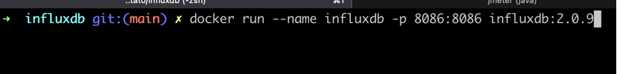

` docker run --name influxdb -p 8086:8086 influxdb:2.0.9`

1. Install influxdb

docker run --name influxdb -p 8086:8086 influxdb:2.0.9

1. Configure Influxdb, open http://localhost:8086

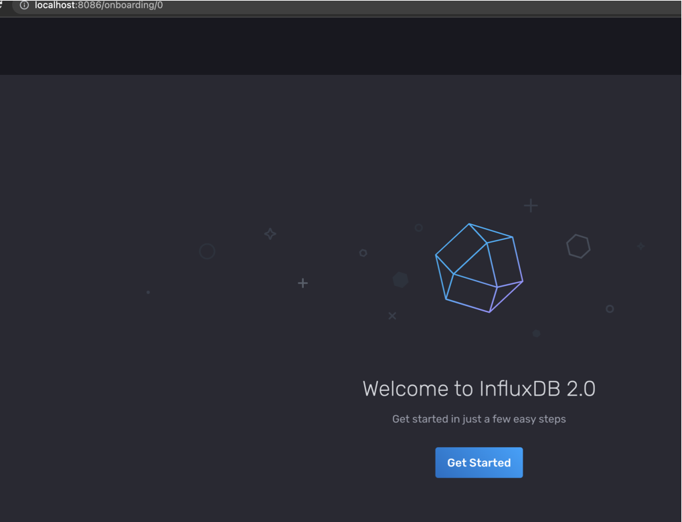

1. Click “Get Started”
2. Fill fields, username, password, organization, backet. Fields organization and bucket you need to use in Jmeter.

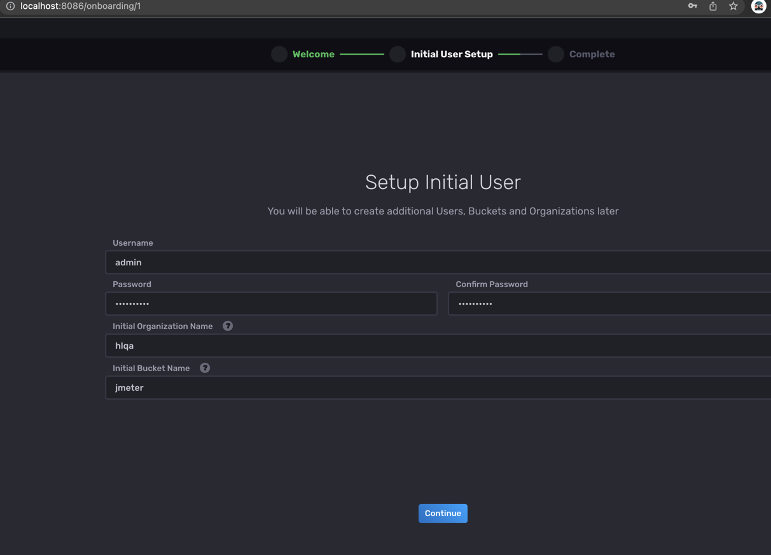

1. Click “Quick Start”

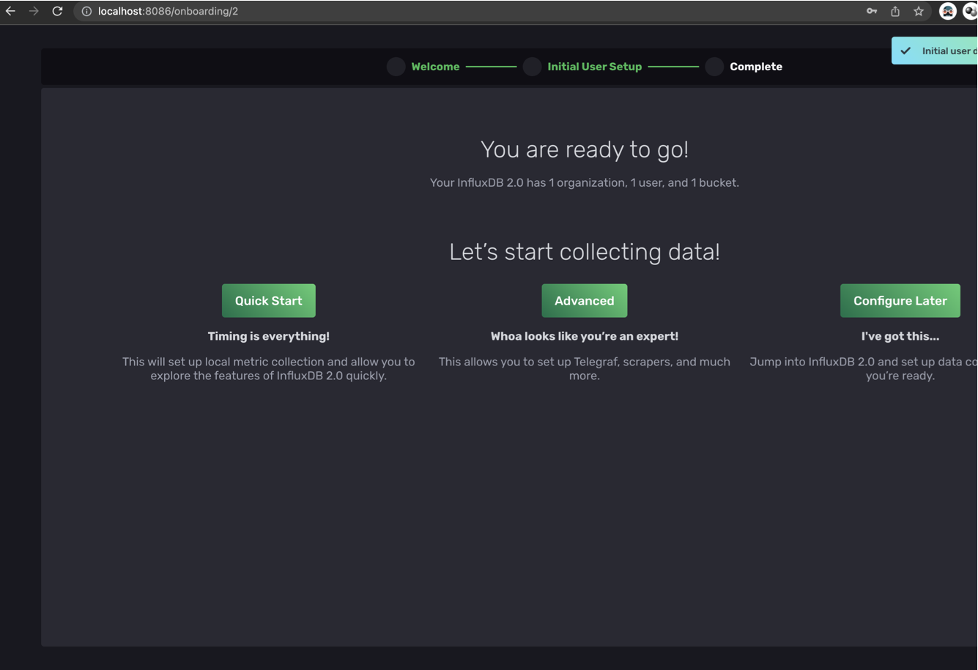

1. Click “Load your data”

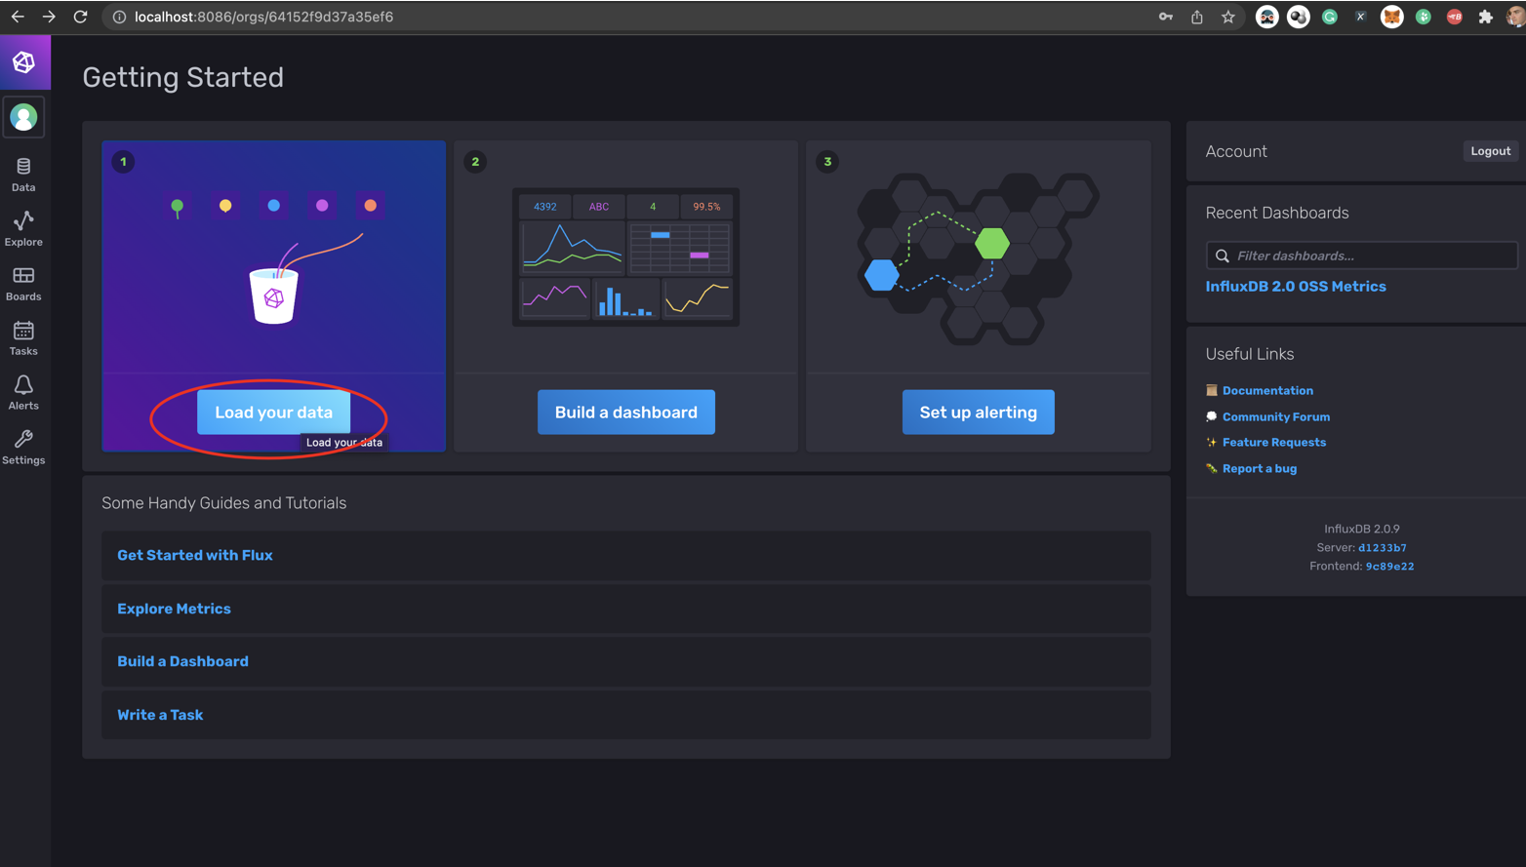

1. Click “tokens”

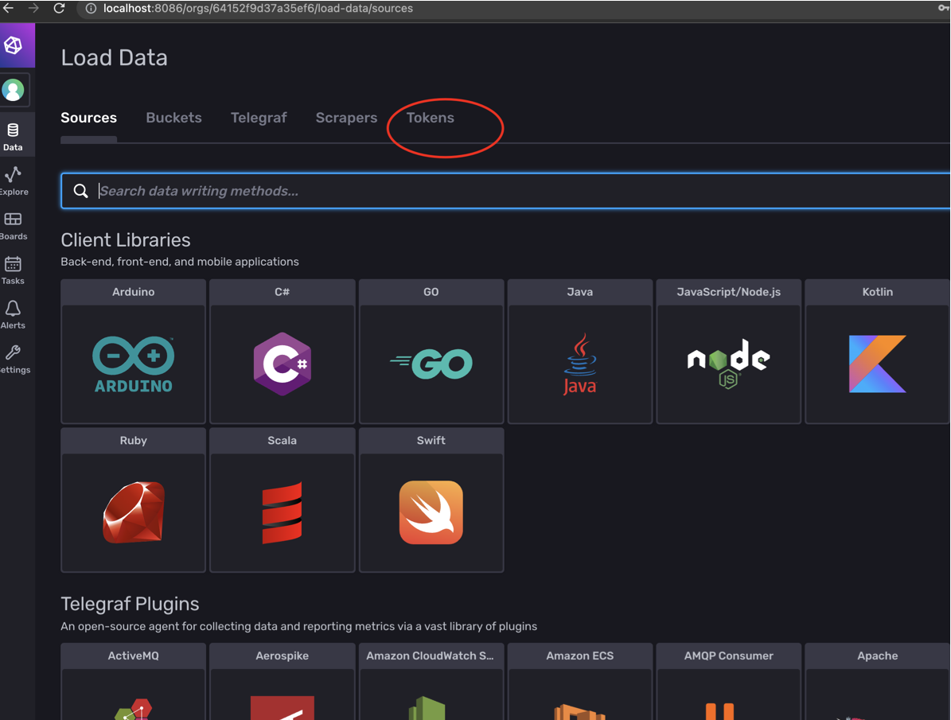

1. Click “Generate Token”> “Read/write Token”.

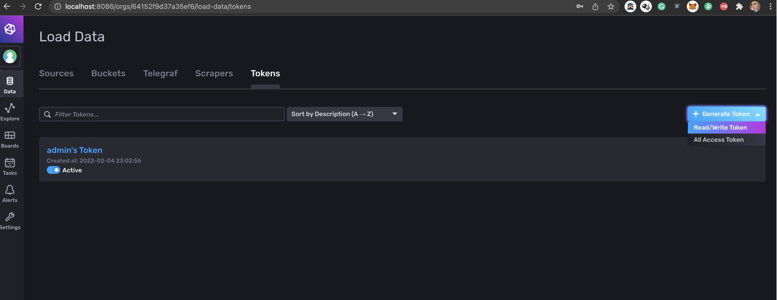

1. Fill field description, choose read/write – jmeter, click “Save”

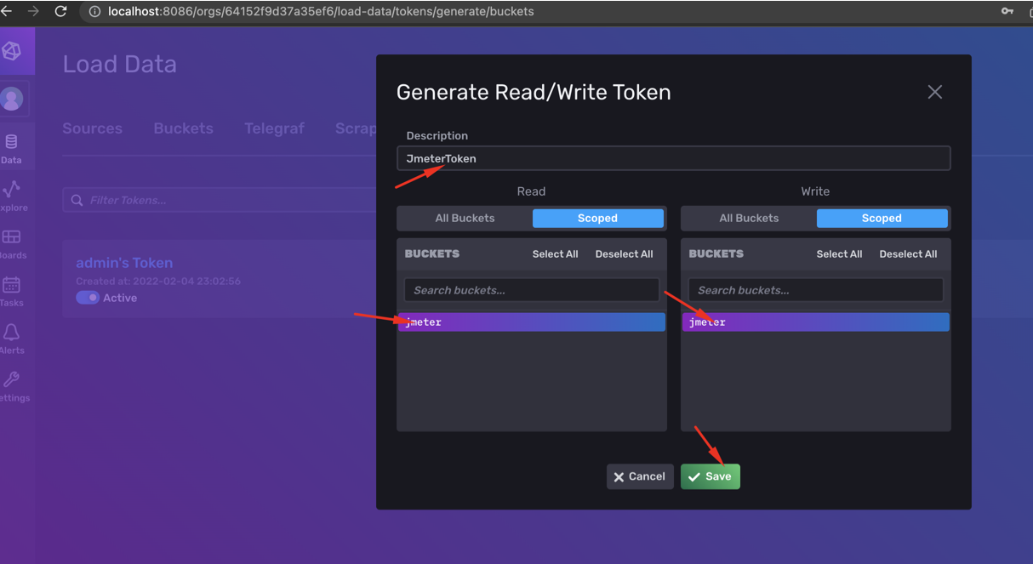

1. Open “JmeterToken”.
2. 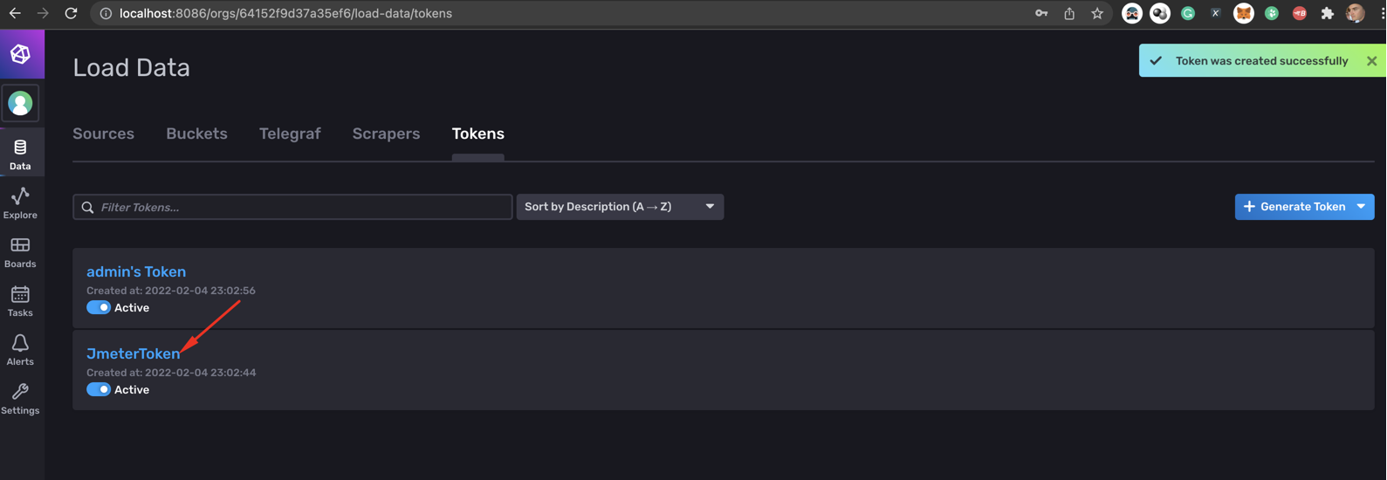
3. Click “Copy to Clipboard”

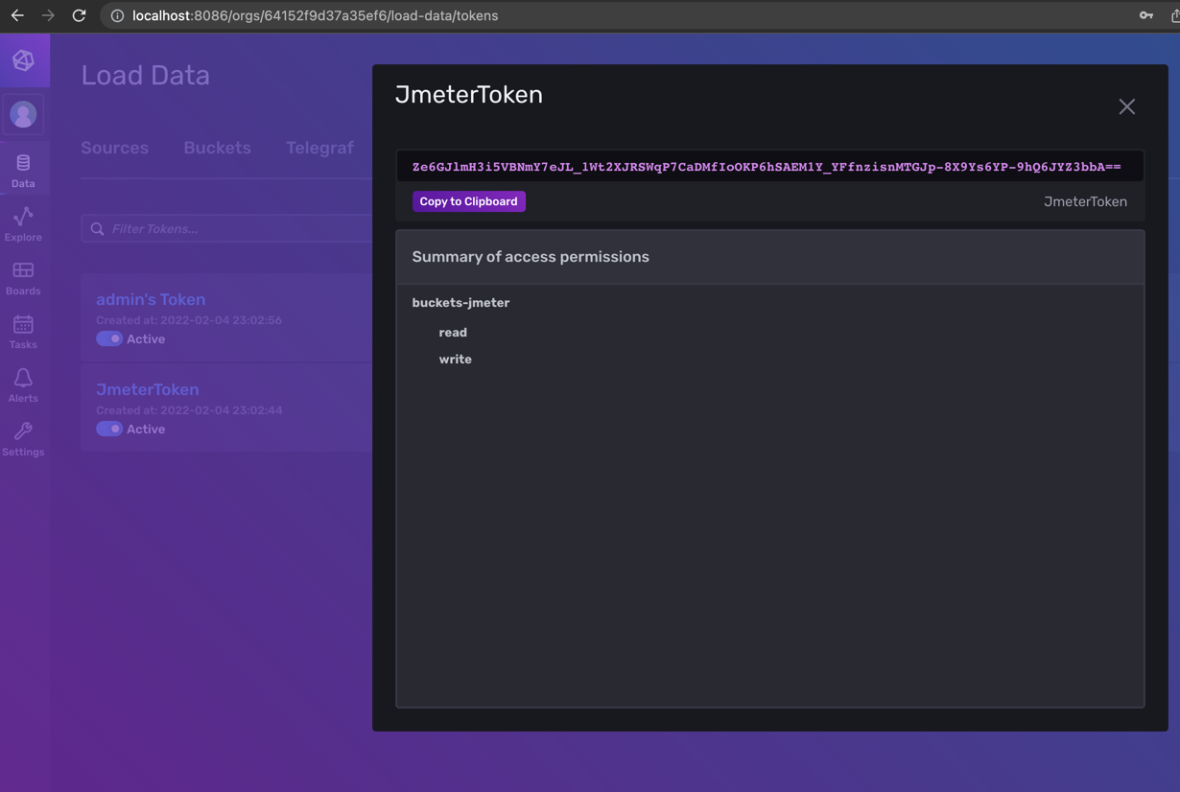

1. Open Apache Jmeter and configure InfluxDB Backend Listener.
2. Set Listener > InfluxdbBackendListenerClient
3. 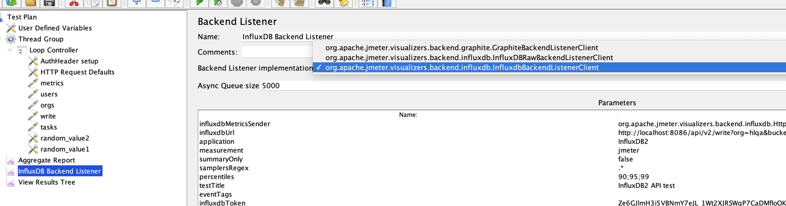
4. Set influxdbUrl > [http://localhost:8086/api/v2/write?org=<ORG>&bucket=<BUCKET>](http://localhost:8086/api/v2/write?org=%3cORG%3e&bucket=%3cBUCKET%3e)

where <ORG> =”hlqa“ and <BUCKET>=”jmeter” - organization and bucket from influxdb setup on step 4, example: http://localhost:8086/api/v2/write?org=hlqa&bucket=jmeter

1. Set InfluxdbToken from step 11. “Ze6GJlmH3i5VBNmY7eJL_1Wt2XJRSWqP7CaDMfIoOKP6hSAEM1Y_YFfnzisnMTGJp-8X9Ys6YP-9hQ6JYZ3bbA==”

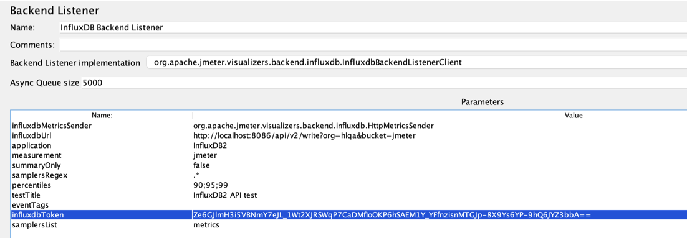

All config example:

|  |  |
| --- | --- |
| influxdbMetricsSender | org.apache.jmeter.visualizers.backend.influxdb.HttpMetricsSender |
| influxdbUrl | http://localhost:8086/api/v2/write?org=hlqa&bucket=jmeter |
| application | InfluxDB2 |
| measurement | jmeter |
| summaryOnly | false |
| samplersRegex | .* |
| percentiles | 90;95;99 |
| testTitle | InfluxDB2 API test |
| eventTags |  |
| influxdbToken | Ze6GJlmH3i5VBNmY7eJL_1Wt2XJRSWqP7CaDMfIoOKP6hSAEM1Y_YFfnzisnMTGJp-8X9Ys6YP-9hQ6JYZ3bbA== |
| samplersList | metrics |

1. Install dashboard to Influxdb, click “Settings”

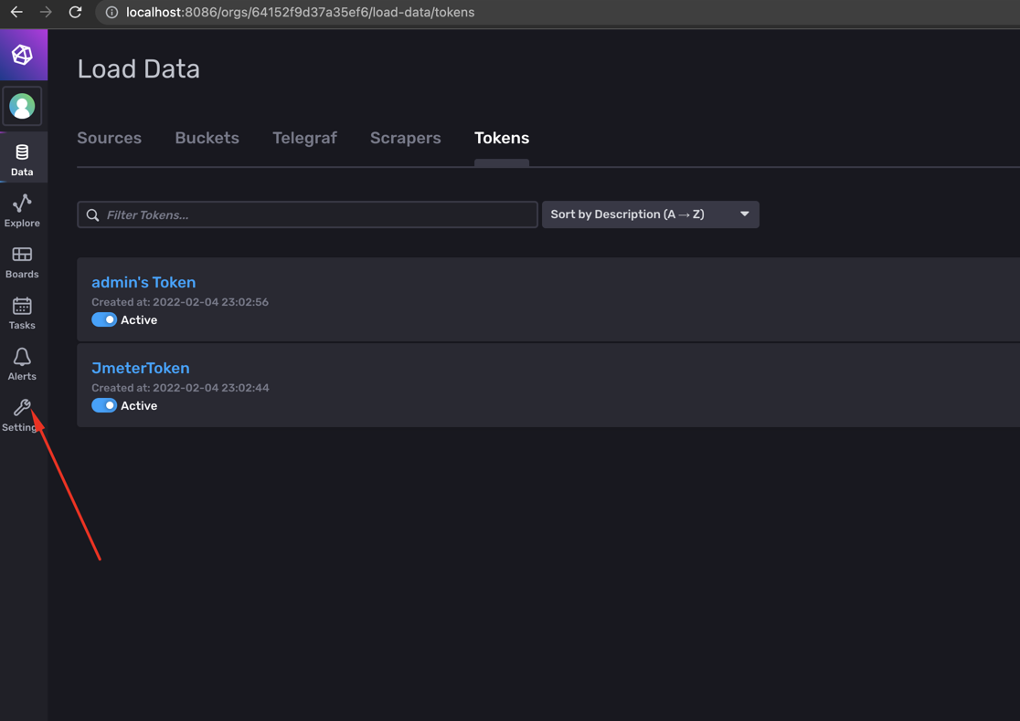

1. Choose “Templates” > “Browse Community Templates”
2. 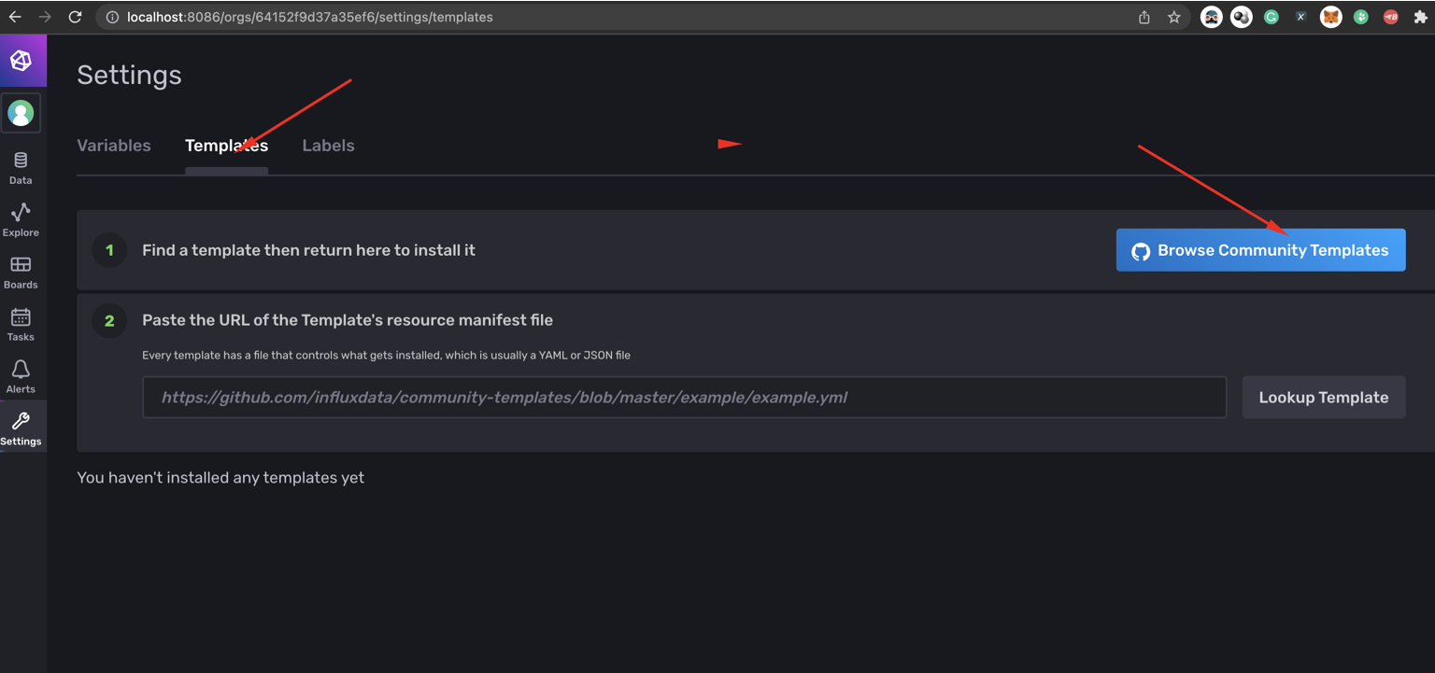
3. Open Jmeter

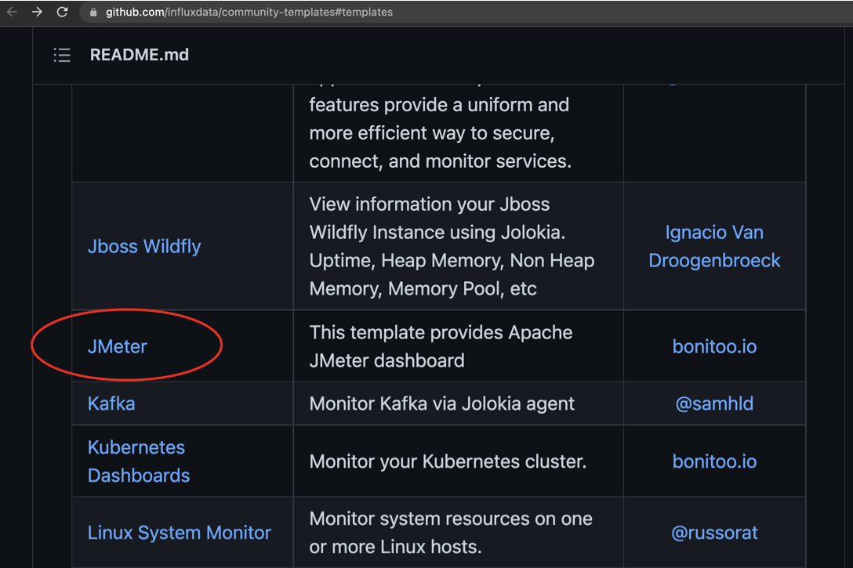

1. Open file “apache_jmeter.yml”.

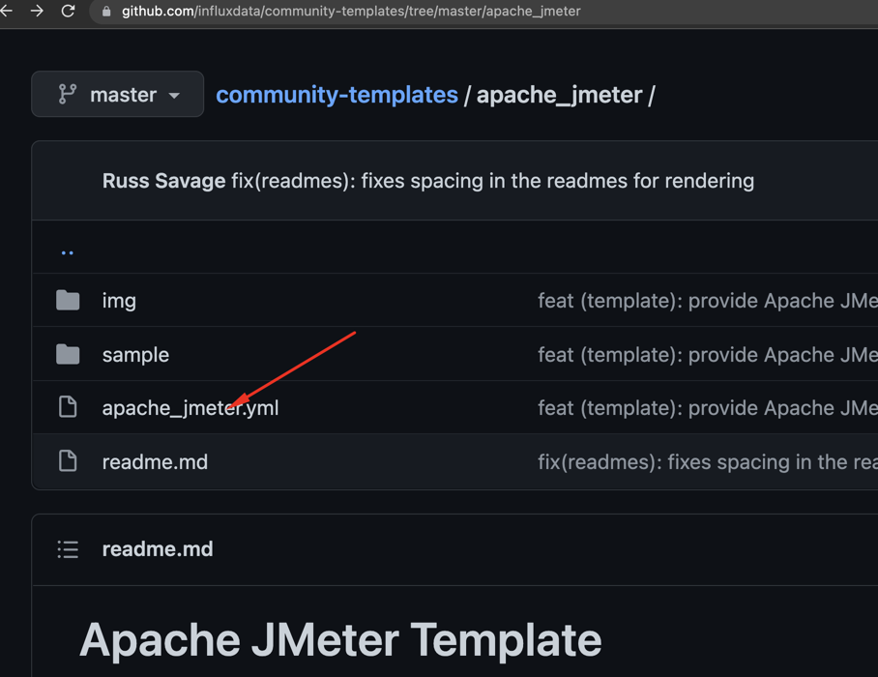

1. Copy page url.

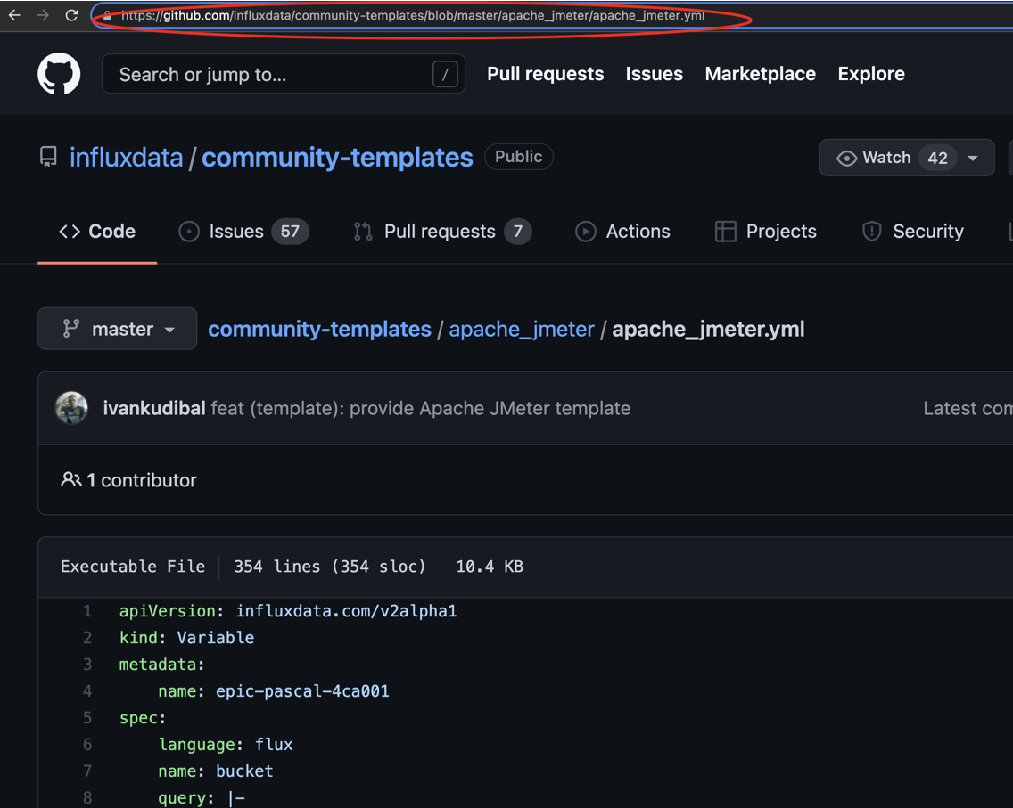

1. Paste the URL of the Template's resource manifest file and click “Lookup Template”.

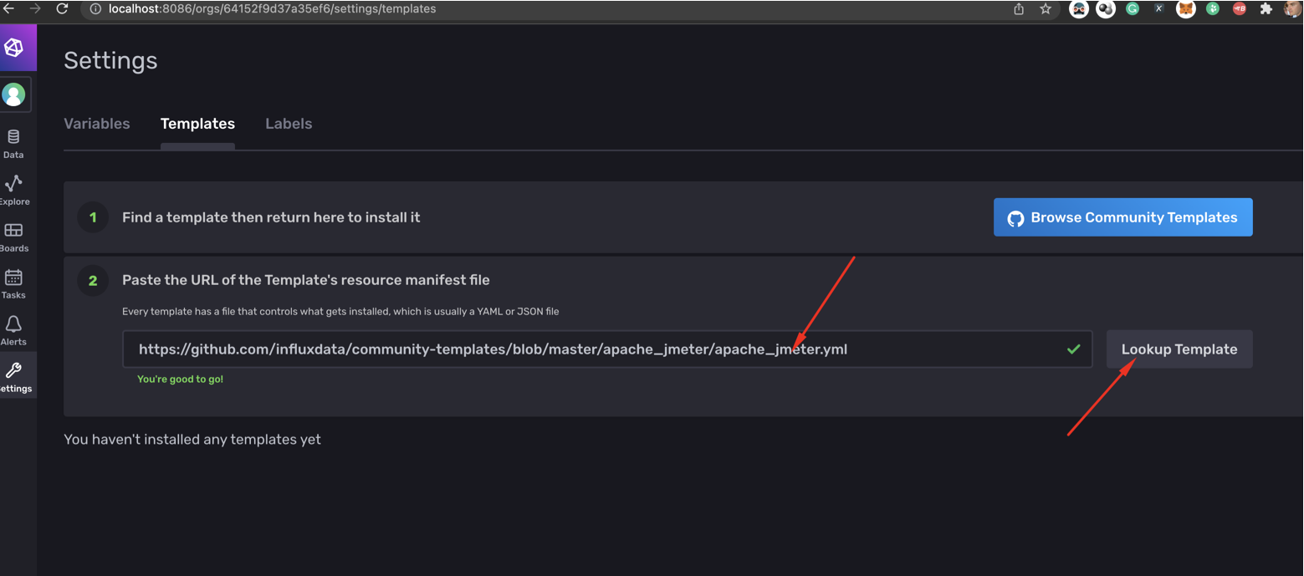

1. Click “Install Template”

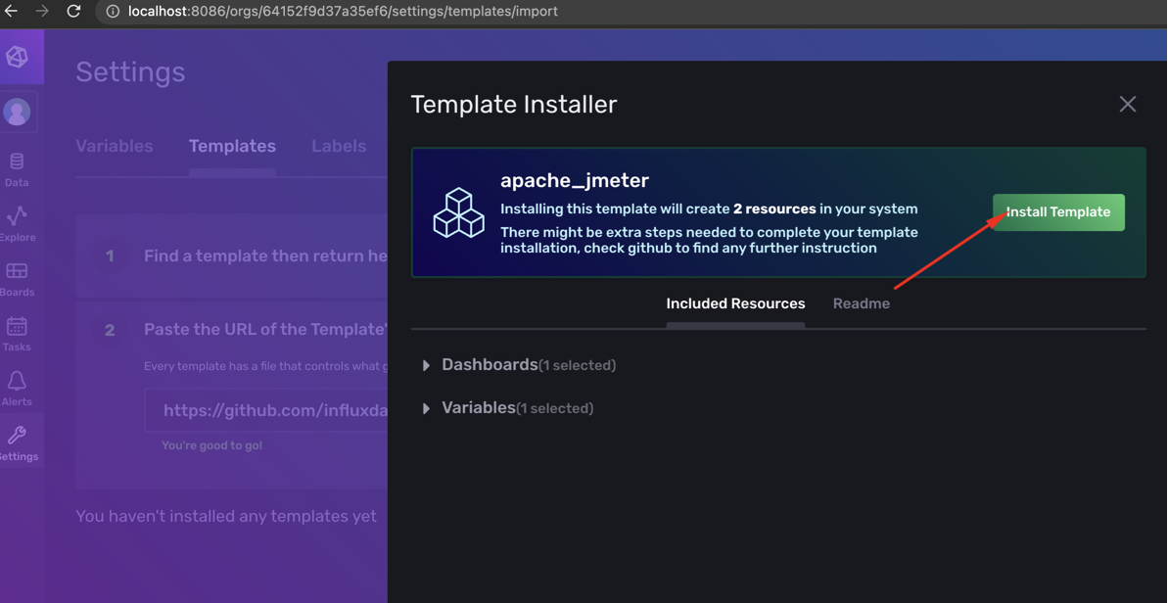

1. Install template finish.

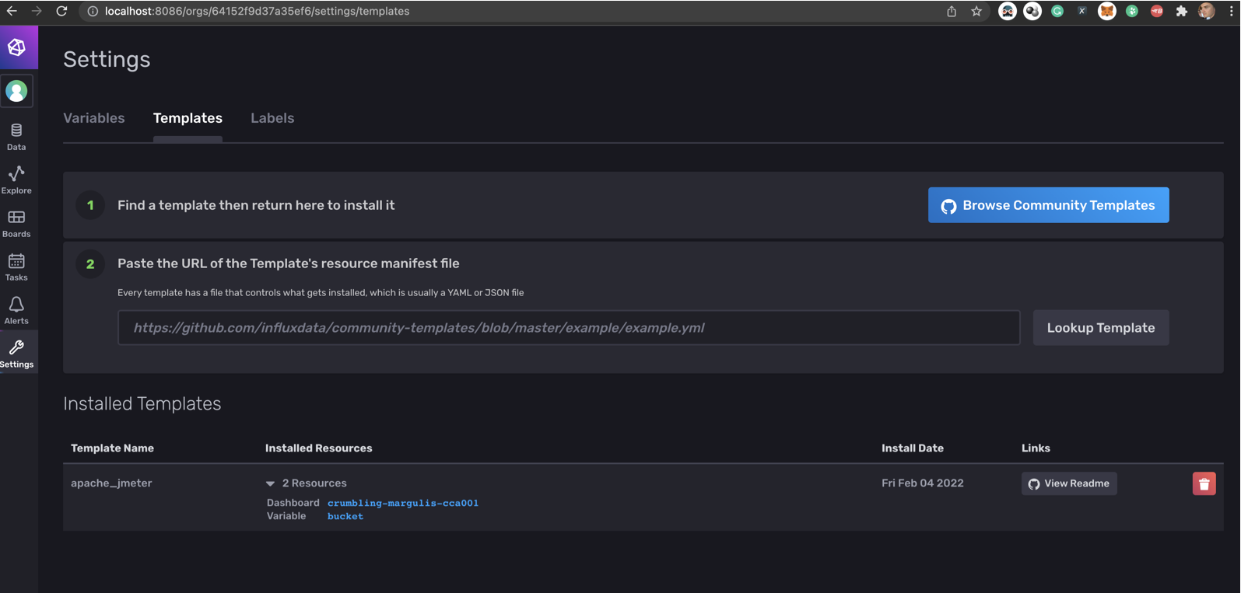

1. Open “Boards”

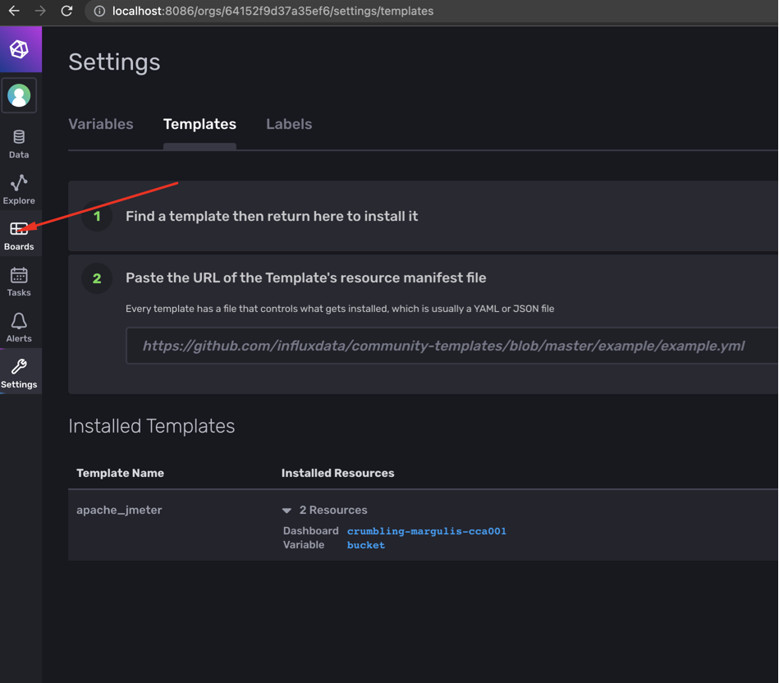

1. Open board “Jmeter”

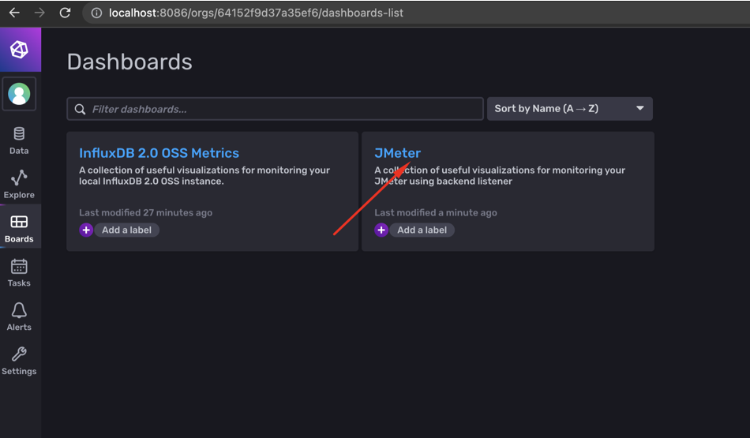

1. Jmeter dashboard before tests.

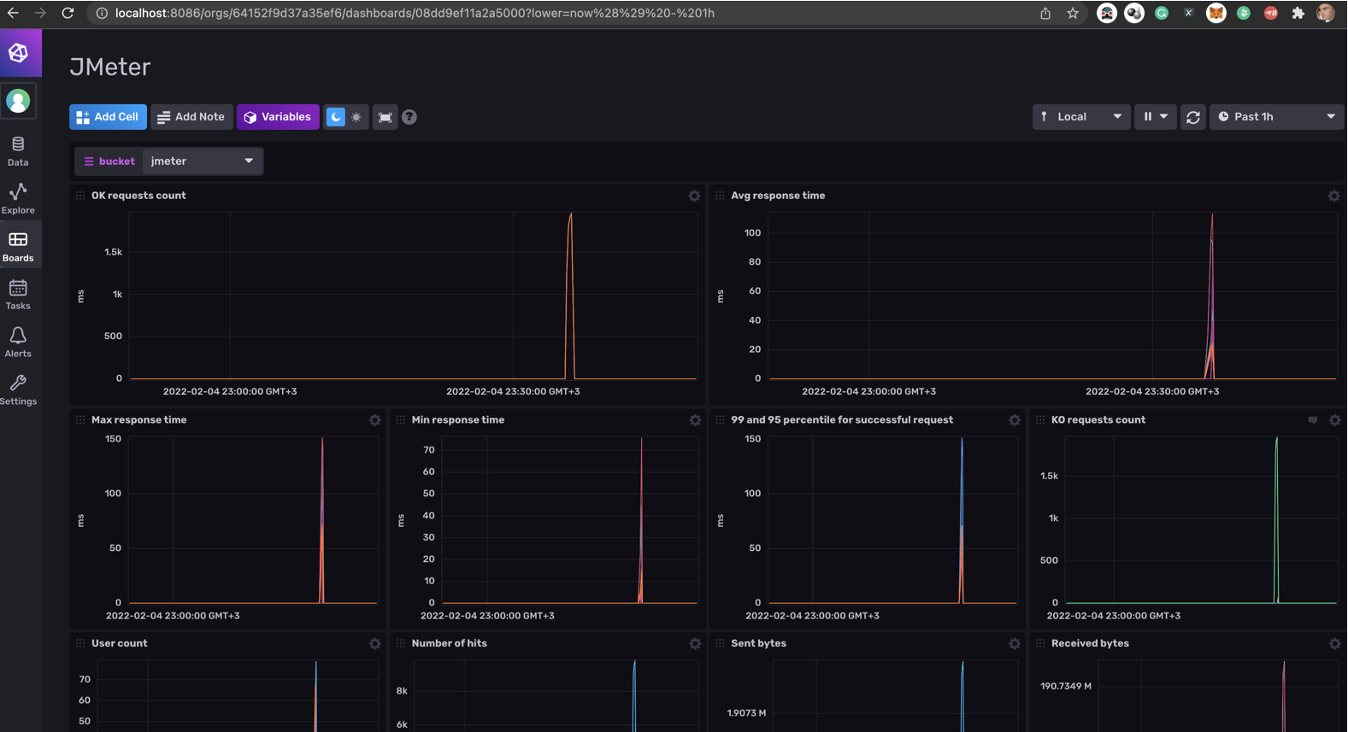

1. Run test from Jmeter. With file “influx_load.jmx”

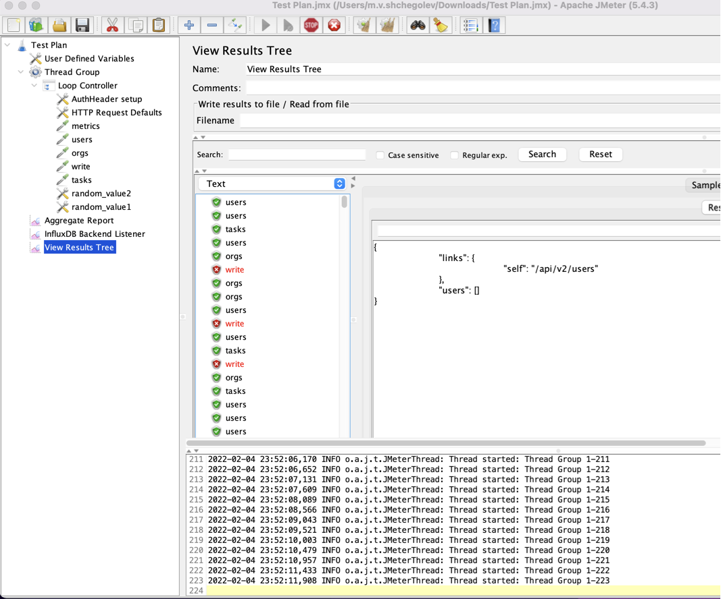

1. Select on dashboard update every 5s.

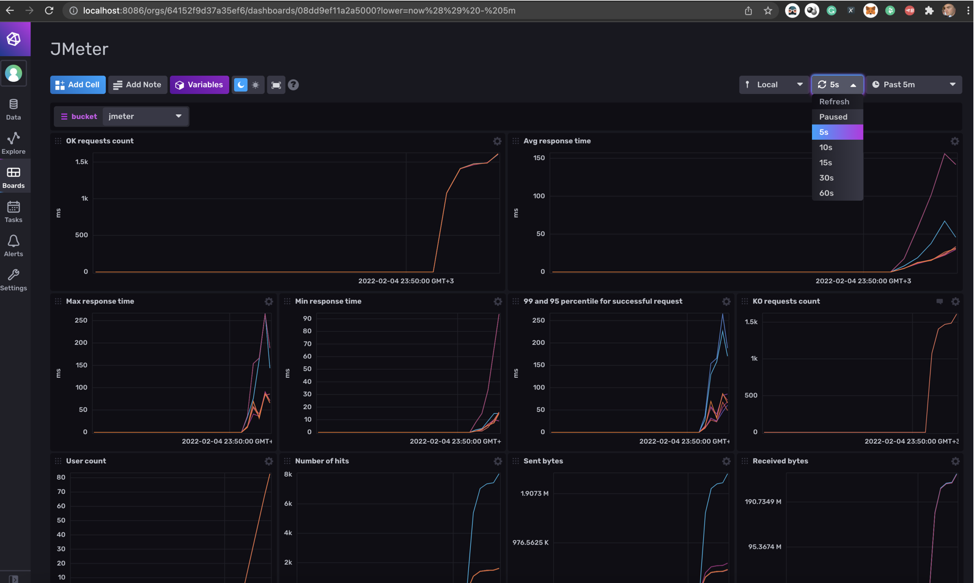

1. Enjoy!
2. Life hack Set variables in “User Defined Variables” and run tests.

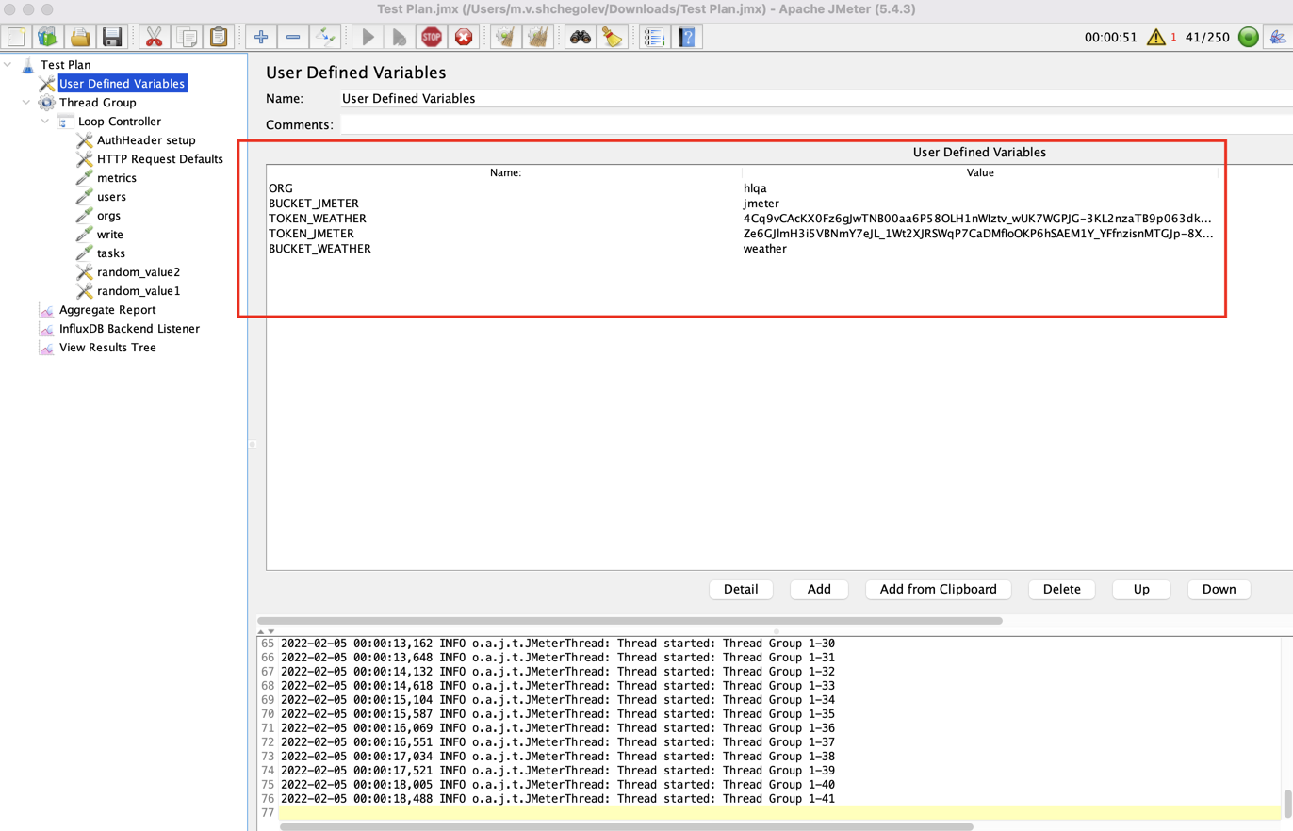

1. Install Grafana

`docker run --name grafana -p 3000:3000 grafana/grafana:latest`

1. Open localhost:3000
2. Add data source, configuration > data source.

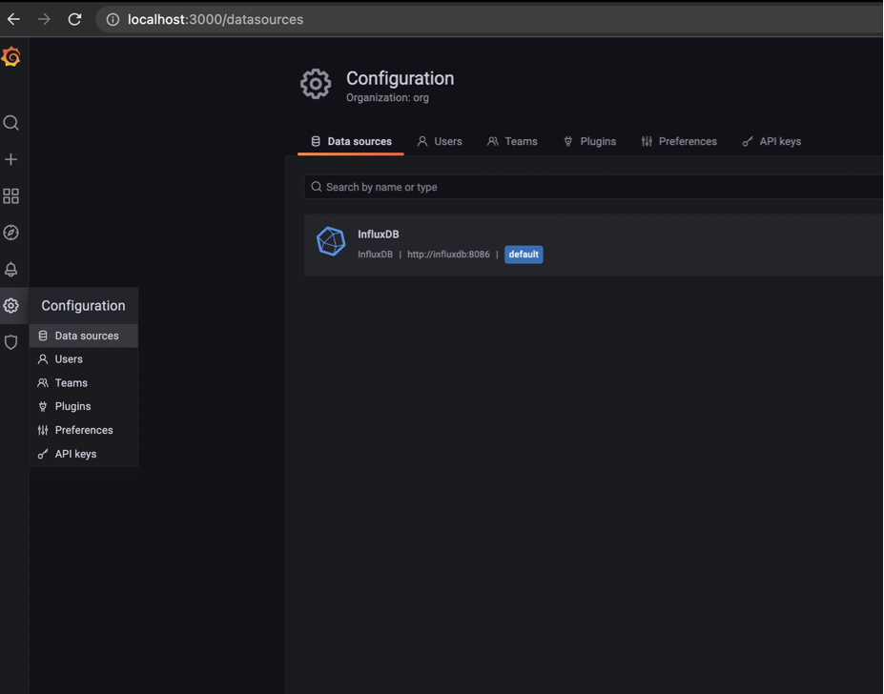

1. Chose InfluxDB.

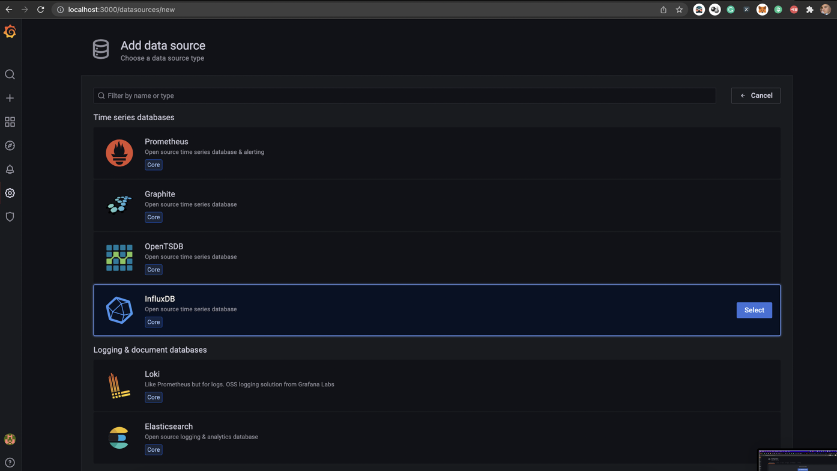

1. Fill fields:
   1. Query language: Flux
   2. URL: <http://influxdb:8086>
   3. Basic auth: off
   4. Organization: hlqa
   5. Token: “Ze6GJlmH3i5VBNmY7eJL_1Wt2XJRSWqP7CaDMfIoOKP6hSAEM1Y_YFfnzisnMTGJp-8X9Ys6YP-9hQ6JYZ3bbA==”
   6. Default bucket: jmeter

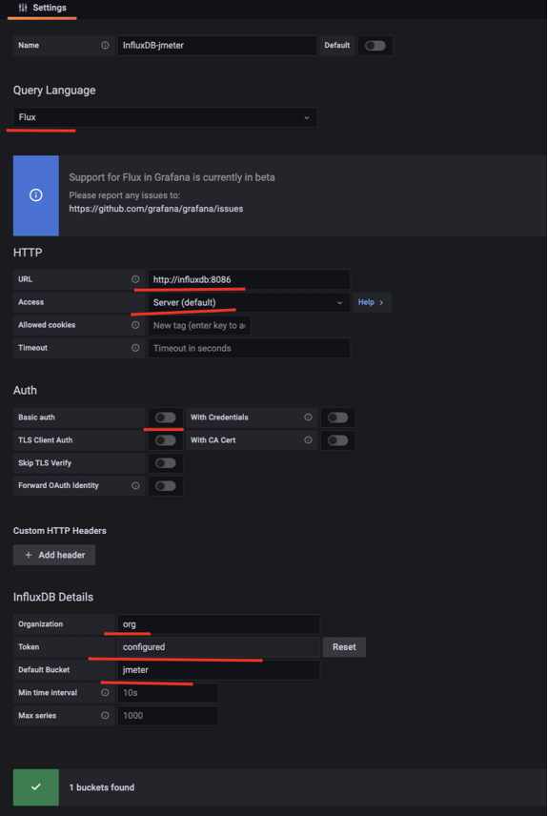

1. Add dashboards, create > Import.

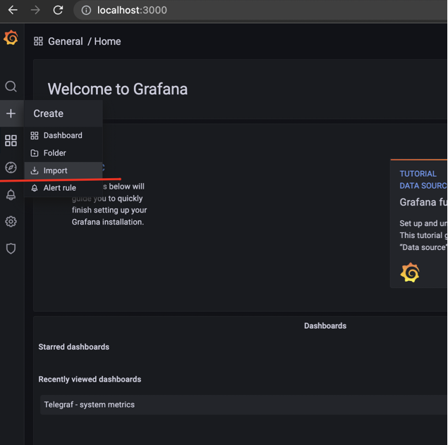

1. Chose template, from local drive or set ID.

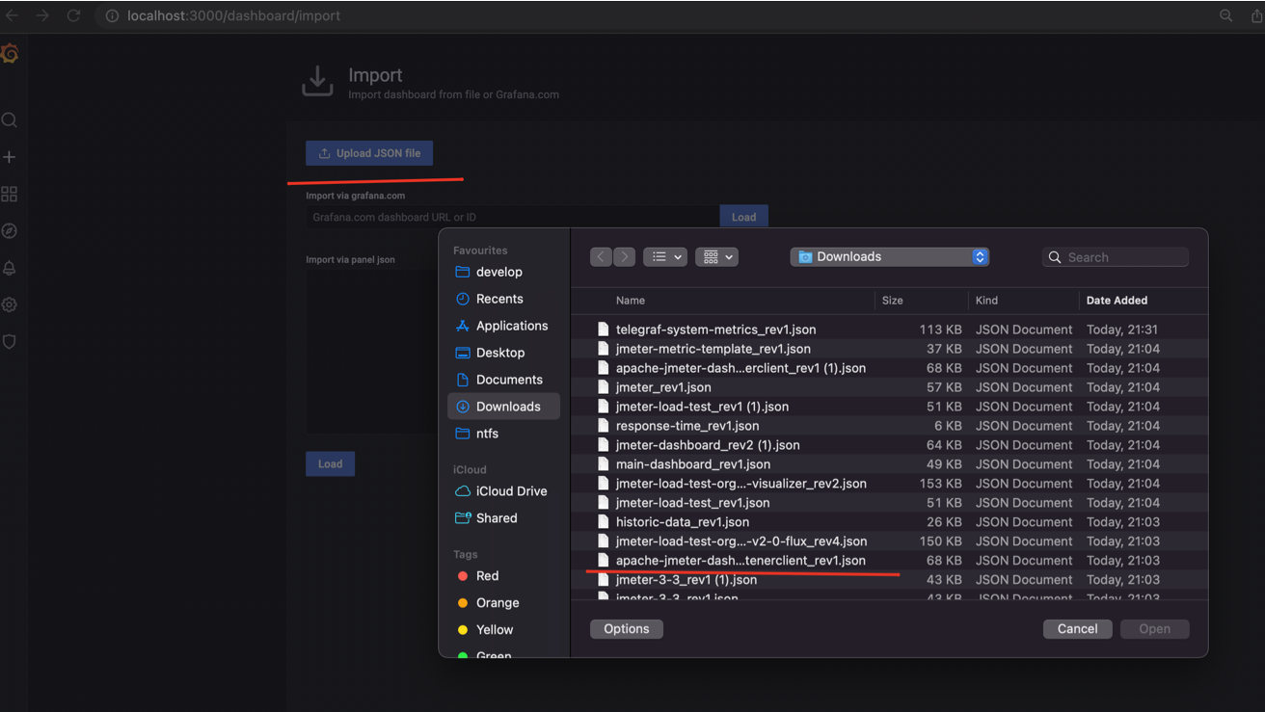

1. Set data source (jmter) and click import.

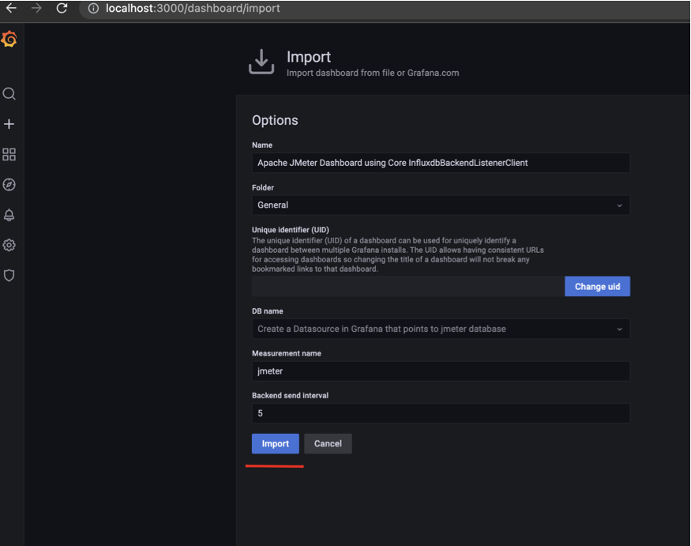

1. Dashboard installed:
2. 